ESPAC

Report 4762/R

On

Fosthiazate

Small scale collaborative trial
for
the determination of Fosthiazate A.I. and formulations
by HPLC

Report to CIPAC
On behalf of
ESPAC

June 2011

Contents Page

1. Participants 3

2. Active ingredient, general information 4

3. Samples 5

4. Method 5

4.1 Scope 5

4.2 Principle 5

4.3 Procedure 5

5. Comments from participants 6

6. Evaluation and discussion 7

6.1 Screening for valid data 7

6.2 Determination of Fosthiazate content 7

Tables 1 – 3 8 - 9
Fig 1 5 - 6
Fig’s 2 6 10 - 12

7. Conclusion 13

1. Participants

Vanessa Lecocq, Christine Collart | Centre wallon de Recherches agronomiques (CRA-W)  Walloon Agricultural Research Centre  Pesticides Research Department  Rue du Bordia, 11  B-5030 GEMBLOUX  BELGIUM
Joe Moreland | Dow AgroSciences Crop Protection R&D  B.P. 20  8, route de Herrlisheim  67410 Drusenheim  France
Andrew Plumb | FERA  Sand Hutton  York  North Yorkshire  YO41 1LZ  England
Teddy Krongaard | National Environmental Research Institute,  University of Aarhus,  Department of Atmospheric Environment  Frederiksborgvej 399, PO Box 358  DK-4000 Roskilde,  Denmark
Jim Garvey | Pesticide Control Laboratory  Backweston Laboratory Campus  Backweston  Youngs Cross  Celbridge  Co. Kildare  Ireland

Participants are listed in alphabetical order whereas laboratory numbers are assigned on the basis of the order in which results were submitted.

2. Active ingredient, general information

Chemical name
O-Ethyl-S-(1-methylpropyl) (2-oxo-3-thiazolidinyl)phosphonothioate

ISO common name

Fosthiazate

CAS No.

98886-44-3

Structural formula

Molecular mass: 283.36

Molecular Formula: C₉H₁₈NO₃PS₂

3. Samples

Two technical materials and three samples of GR formulations (granules) were sent to the participants, these are listed below. Participants in the trial also received an analytical standard with a purity of 99.9%.

1. Technical material 1
2. Technical material 2
3. 10 GR1
4. 10 GR2
5. 10 GR3

4. Method

4.1 Scope

Determination of Fosthiazate content in technical materials and in GR formulations.

4.2 Principle

Fosthiazate is determined by reversed phase high performance liquid chromatography using UV detection at 220 nm and internal standard calibration. A single point calibration was used for the determinations.

4.3 Procedure

See attached method for details.

Fig 1a Fosthiazate technical material

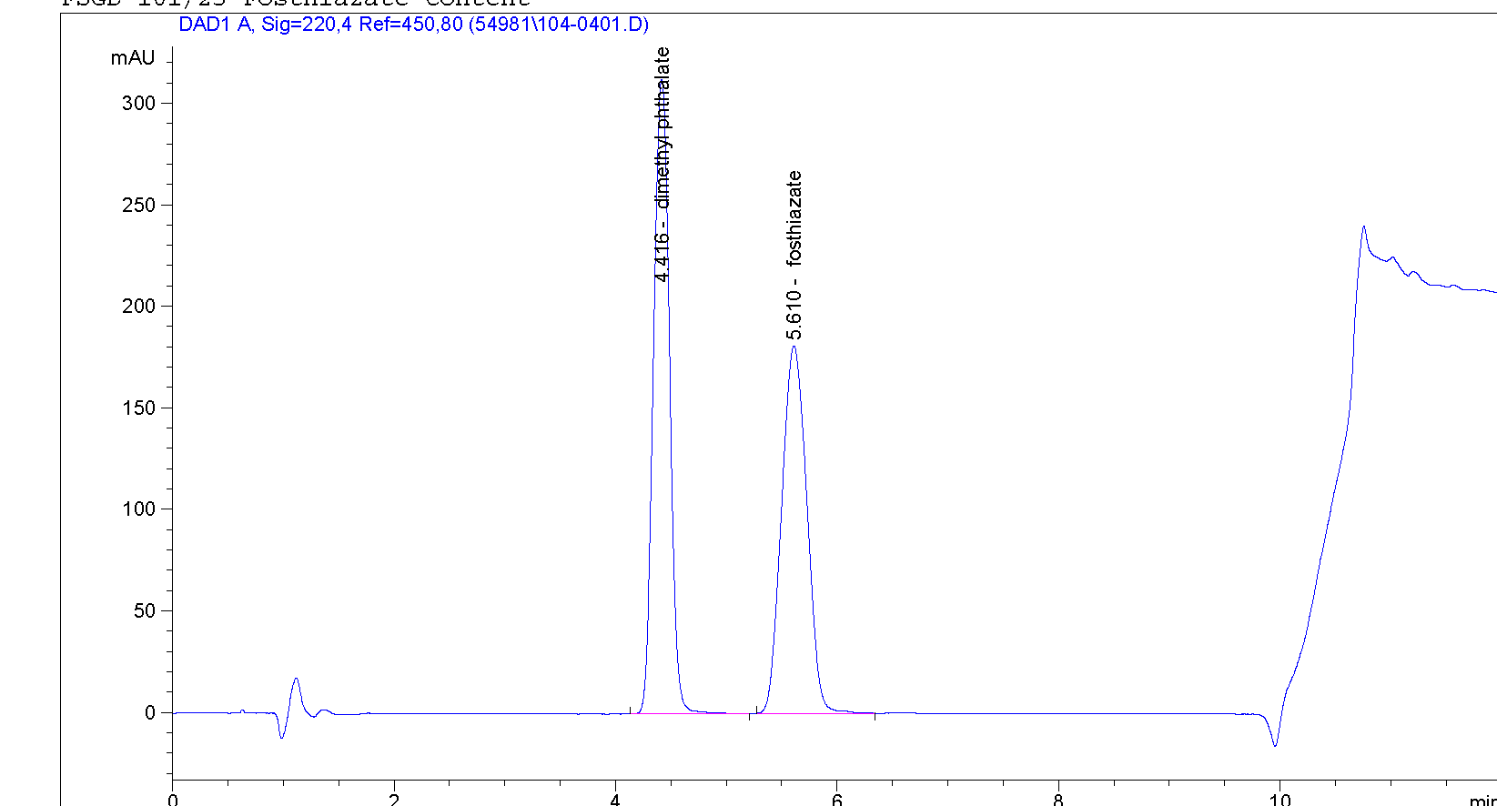

Fig 1b Fosthiazate GR fornulation

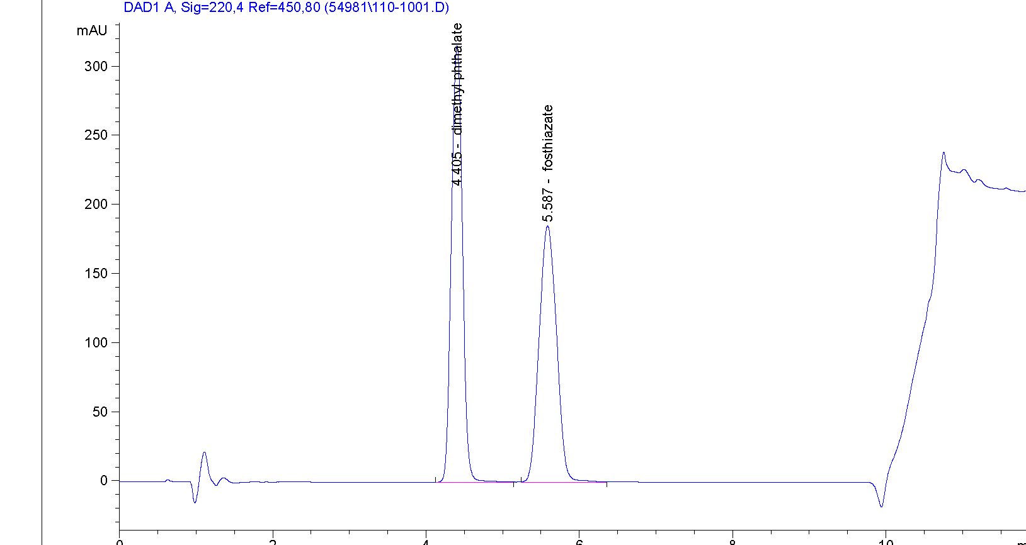

5. Comments from the Participants.

The following comments were received from the study participants.

Lab 1 There was a mistake in the results sheet when calculating the results in g/kg.

Lab 2 As the method is internal standard did not see the need to use volumetric glassware.
Standard weight of 24mg is very low and below are normal minimum weight limit.

Lab 3 GR samples were centrifuged but did not feel it necessary to do this as well as filter

Lab 4 We weighed 43 mg (2 droplets) instead of 24 mg active ingredient, which was difficult to achieve.

Lab 5 HYPERCLONE ODS C18 125mm x 4.0mm 5um column was used

6. Evaluation and Discussion
6.1 Screening for valid data
The statistical evaluation was carried out according to the guidelines in the CIPAC document “Guideline for CIPAC collaborative studies Procedure for Assessment of Performance of Analytical Methods. The data was tested for outliers and stragglers firstly using Cochran’s test on the within laboratory variance and then using Grubbs test on laboratory means to test the between laboratory variance. The tests were carried out at the alpha level of 0.01 for outliers and 0.05 level for stragglers.

The results from Lab 2 showed up as outliers by Cochran’s variance test for the two technical materials and 10GR3. The result from Lab 2 was also a Grubbs straggler for the Tech 1 material and the 10WG3 formulation. No data was excluded from the initial evaluation.

6.2 Determination of active ingredient content

The results obtained for laboratories 1 – 5 are given in Tables 1-3 and Fig’s 2 – 6.

Both technical materials meet the Horowitz criteria. For the 10WG formulations the Horowitz criteria are not met in the initial screening. The only outlier is lab 2 for the 10WG3 formulation. Removal of this outlier makes no difference to the statistical calculations.
Data

Table 1 – Results summary by lab for all the samples

Day 1 |  | Day 2 |  | Mean | s | Day 1 |  | Day 2 |  | Mean | s
964.4 | 970.6 | 970.6 | 969.6 | 968.8 | 3.0 | 958.5 | 964.1 | 961.3 | 963.6 | 961.9 | 2.6
976.0 | 968.7 | 1010.0 | 1003.9 | 989.6 | 20.3 | 960.3 | 965.9 | 1000.6 | 1007.6 | 983.6 | 24.0
960.7 | 961.8 | 963.7 | 963.3 | 962.3 | 1.4 | 963.0 | 962.2 | 962.6 | 966.0 | 963.5 | 1.7
951.4 | 956.8 | 965.2 | 970.7 | 970.7 | 8.6 | 951.8 | 956.2 | 965.1 | 961.3 | 958.6 | 5.8
966.0 | 967.4 | 964.4 | 955.8 | 963.4 | 5.2 | 963.7 | 964.7 | 970.1 | 967.0 | 966.4 | 2.8
Day 1 |  | Day 2 |  | Mean | s | Day 1 |  | Day 2 |  | Mean | s | Day 1 |  | Day 2 |  | Mean | s
103.3 | 105.0 | 104.3 | 108.7 | 105.3 | 2.4 | 101.6 | 103.2 | 105.7 | 101.3 | 103.0 | 2.0 | 112.6 | 105.5 | 108.3 | 107.5 | 108.5 | 3.0
101.6 | 107.2 | 107.8 | 107.9 | 106.1 | 3.0 | 100.3 | 98.4 | 104.7 | 102.5 | 101.5 | 2.7 | 0.0 | 106.9 | 112.2 | 113.8 | 110.9 | 55.6
103.3 | 102.2 | 110.1 | 109.4 | 106.2 | 4.1 | 96.2 | 96.6 | 101.8 | 100.6 | 98.8 | 2.8 | 103.0 | 101.8 | 101.2 | 102.7 | 102.7 | 0.8
106.6 | 108.2 | 106.7 | 107.5 | 107.3 | 0.8 | 100.9 | 101.4 | 104.1 | 99.7 | 101.5 | 1.9 | 104.1 | 105.4 | 105.8 | 105.6 | 105.2 | 0.8
101.6 | 106.8 | 104.2 | 112.2 | 106.2 | 4.5 | 97.1 | 98.2 | 98.7 | 100.0 | 98.5 | 1.2 | 109.1 | 109.3 | 109.2 | 106.1 | 108.4 | 1.6

Cochran’s stragglers
Cochran outliers
Grubb’s straggler
Grubb’s outlier

Table 2 Summary of statistical evaluation – No outliers removed

 | Tech 1 | Tech 2 | 10GR1 | 10GR2 | 10GR3
X_{m} (g/kg) | 969.0 | 966.8 | 106.2 | 100.7 | 101.5
L | 5 | 5 | 5 | 5 | 5
S_{r} | 10.25 | 11.18 | 3.23 | 2.21 | 2.27
S_{L} | 13.25 | 12.18 | 2.46 | 2.59 | 3.41
S_{R} | sR | 12.18 | 4.06 | 3.40 | 4.10
r | 28.71 | 31.30 | 9.05 | 6.18 | 6.36
R | 37.10 | 34.11 | 11.37 | 9.53 | 11.48
RSD_{r} | 1.06 | 1.16 | 3.04 | 2.19 | 2.24
RSD_{R} | 1.37 | 1.26 | 3.82 | 3.38 | 4.04
RSD_{R} (Hor) | 2.01 | 2.01 | 2.80 | 2.83 | 2.80

Table 3 – Statistical evaluation on exclusion of the data for Lab 2 from the 10GR1 and 10GR2

 | Tech 1 | Tech 2 | 10GR1 | 10GR2 | 10GR3
Xm (g/kg) | 969.0 | 966.8 | 106.2 | 100.7 | 101.5
L | 5 | 5 | 5 | 5 | 4
Sr | 10.25 | 11.18 | 3.23 | 2.21 | 2.27
SL | 13.25 | 12.18 | 2.46 | 2.59 | 3.41
SR | 13.25 | 12.18 | 4.06 | 3.40 | 4.10
r | 28.71 | 31.30 | 9.05 | 6.18 | 6.36
R | 37.10 | 34.11 | 11.37 | 9.53 | 11.48
RSDr | 1.06 | 1.16 | 3.04 | 2.19 | 2.24
RSDR | 1.37 | 1.26 | 3.82 | 3.38 | 4.04
RSDR (Hor) | 2.01 | 2.01 | 2.80 | 2.83 | 2.80

X_{m} = Overall sample mean
L = Number of laboratories
S_{r} = Repeatability standard deviation
RSD_{r} = Relative repeatability standard deviation
r = Repeatability limit
S_{R} = Reproducibility standard deviation
RSD_{R} = Relative reproducibility standard deviation
R = Reproducibility limit
S_{L} = “pure” between laboratory standard deviation
RSD_{R} (Hor) = Relative reproducibility standard deviation (Horowitz equation)

Fig 2 – Tech 1

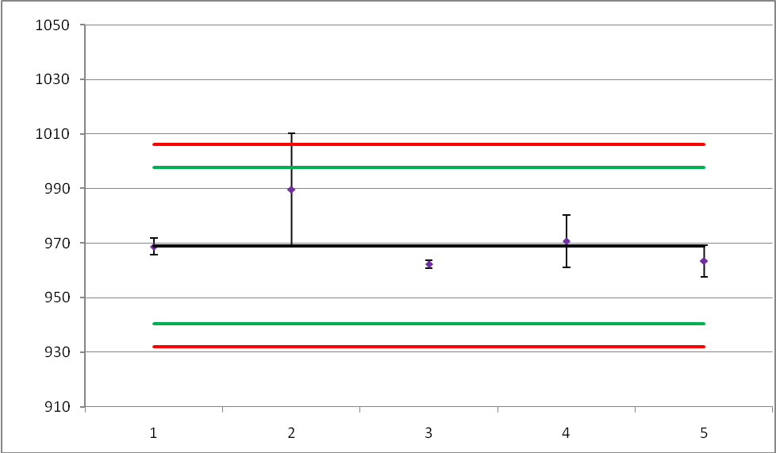
Dark line: overall mean
Green lines: r limits
Red lines: R limits

Fig 3 – Tech 2

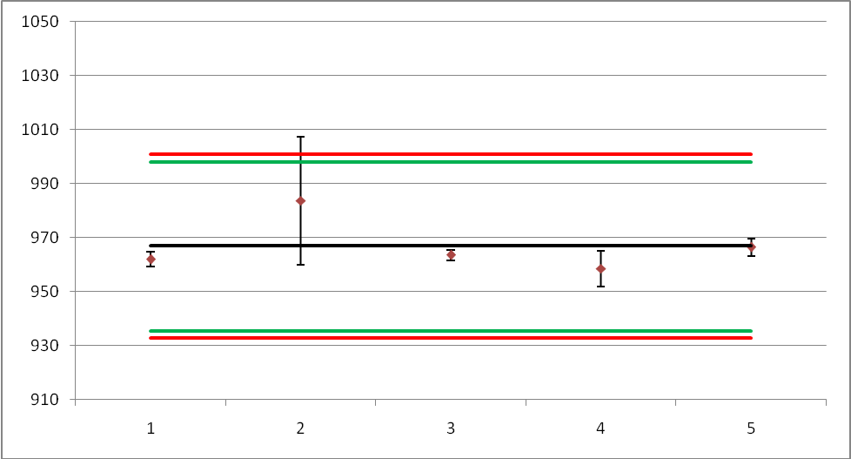
Dark line: overall mean
Green lines: r limits
Red lines: R limits

Fig 4 – 25GR1

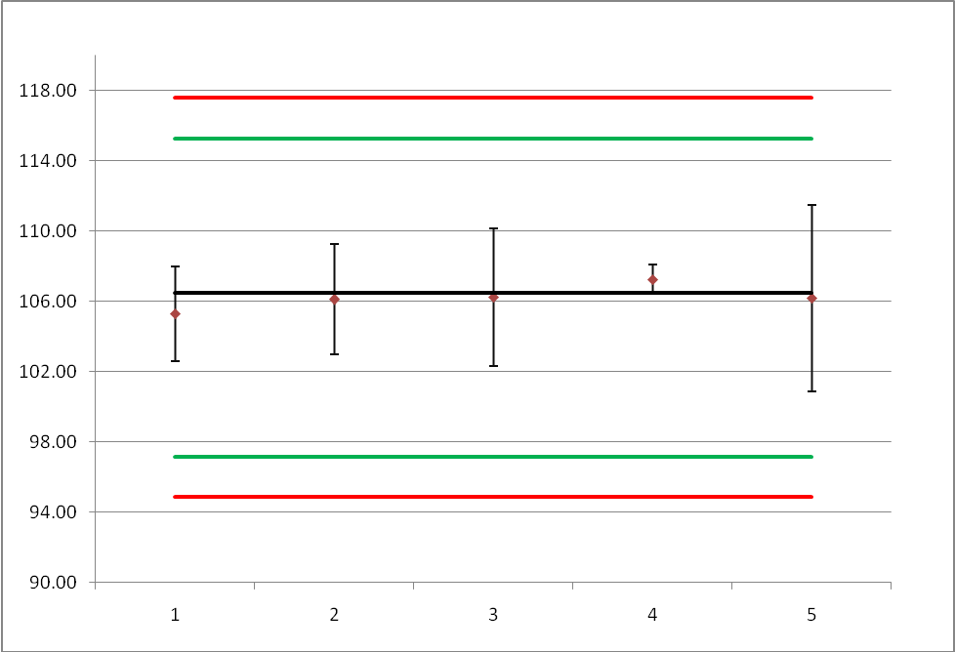
Dark line: overall mean
Green lines: r limits
Red lines: R limits

Fig 5 – 25GR2

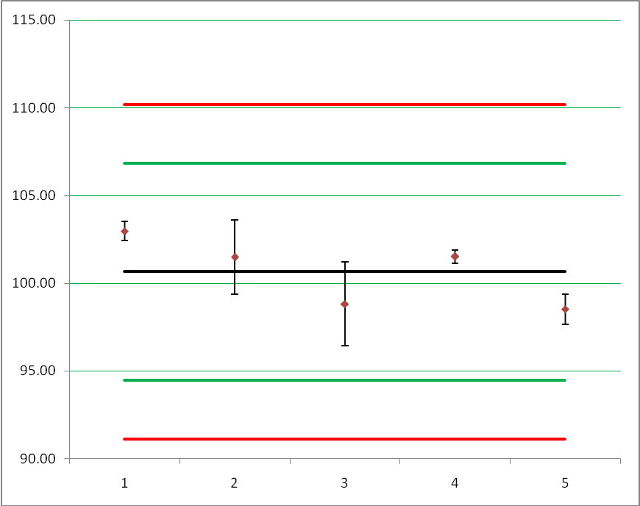
Dark line: overall mean
Green lines: r limits
Red lines: R limits

Fig 6 – 25GR3

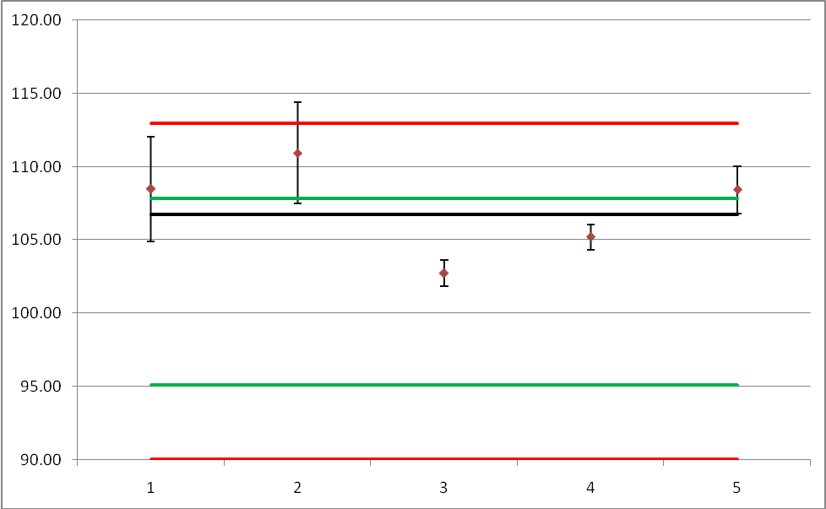

Dark line: overall mean
Green lines: r limits
Red lines: R limits

7. Conclusion

Five laboratories received samples for this collaborative trial and all of these laboratories submitted results. After the initial evaluation the calculated Reproducibility Standard Deviation (RSD_{R}) and the Repeatability Relative Standard Deviation (RSD_{r}) met the Horowitz criteria for both Technical materials.

All three 10GR formulations did not meet the Horowitz criteria. Removal of the outliers did not improve this situation. One possible reason for this is that the sample size is not large enough to get a representative sample with this type of formulation. ESPAC recommends that a larger sample (at least 5g) is extracted and a sub-sample of this is used for analysis.

Acknowledgement:

ESPAC would like to express our gratitude to Frederic Joris and Laura Drukteinyte and their colleagues at ISK for supplying and distributing the samples and standards used in this Collaborative study.

